Project:- E-learning

**PROJECT REPORT ON E-LEARNING WEB SITE**

**ACADEMIC YEAR 2022-2023**

**PROJECT GUIDE**

**Prof. Abhishek Gulati**

**Prof. Vicky Patil**



**Group Members:**

**Suraj Pawar**

**Shreyas Repale**

**SUBMITTED TO**

**MICROSOFT AZURE**

E-LEARNING

**Title:** Deployment of E-Learning Website using IIS, Load balancer, recovery vault and traffic manager.

### Software Requirements:

* + - Operating system: Windows 10/11 or MAC OS.
    - Platform: Microsoft Azure
    - Microsoft azure subscription(Free Trial or Azure for student or Pay-as-you-go)
    - WORDPRESS for creation of website programming language: HTML, PHP
    - Virtual machine OS: window2022

### Hardware Requirements:

* + - Processor: Intel core i5 and above
    - Hard disk: 256 GB or above
    - RAM: 4GB or above
    - Internet: 1 Mbps or above
    - Virtual machine ram: 1GB
    - Virtual machine storage: 30Gb

**Procedure**

Step1**:** Establish a Virtual Network (V-Net) that contains a subnet, and within that subnet(webserver), place a Virtual Machine (VM)

Step2:-now create a two Virtual machine name VM1 and VM2

in one subnet

Step3:- Now connect VM1 and VM2 after connecting VM add feature web server(IIS) install the IIS future

Step4: Now deploy web site in VM1 And VM2

Step5: Go to azure portal and check web site working or not ,copy the VM1 IP and paste portal

Step6: Now a create load balancer and add VM’s in load balancer

Load balancer: *Load balancing* refers to efficiently distributing incoming network traffic across a group of backend servers or resources. It is distributed equally internet traffic toward the available healthy server.

Step 7:- Now create recovery vault and add VM1 and VM2 for backup vm’s purpose.

A Recovery Services vault is a storage entity in Azure that houses data. The data is typically copies of data, or configuration information for virtual machines (VMs), workloads, servers, or workstations. You can use Recovery Services vaults to hold backup data for various Azure services such as IaaS VMs (Linux or Windows) and SQL Server in Azure VMs.

Step8:-Afte that we have also create traffic manager

Azure Traffic Manager is a DNS-based traffic load balancer. This service allows you to distribute traffic to your public facing applications across the global Azure regions. Traffic Manager also pro vides your public endpoints with high availability and quick responsiveness.

**Azure Services Used:**

### Azure VM

### Load balancer

### Recovery vault

### Traffic manager

### 1.Azure VM

Azure virtual machines are one of several types of [on-demand, scalable computing](https://learn.microsoft.com/en-us/azure/architecture/guide/technology-choices/compute-decision-tree) [resources](https://learn.microsoft.com/en-us/azure/architecture/guide/technology-choices/compute-decision-tree) that Azure offers. Typically, you choose a virtual machine when you need more control over the computing environment than the other choices offer. This article gives you information about what you should consider before you create a virtual machine, how you create it, and how you manage it.

An Azure virtual machine gives you the flexibility of virtualization without having to buy and maintain the physical hardware that runs it. However, you still need to maintain the virtual

machine by performing tasks, such as configuring patching, and installing the software that runs on it.

**Applies to:** ✔️ Linux VMs ✔️ Windows VMs ✔️ Flexible scale sets

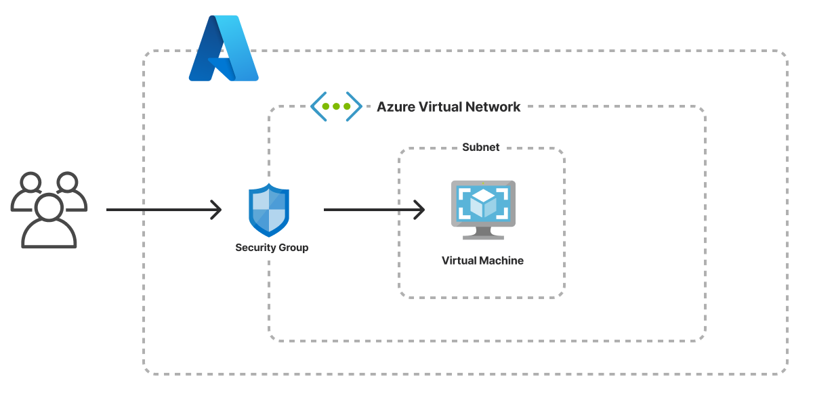

### 2.Load balancer:-

*Load balancing* refers to efficiently distributing incoming network traffic across a group of backend servers or resources. It is distributed equally internet traffic toward the available healthy server.

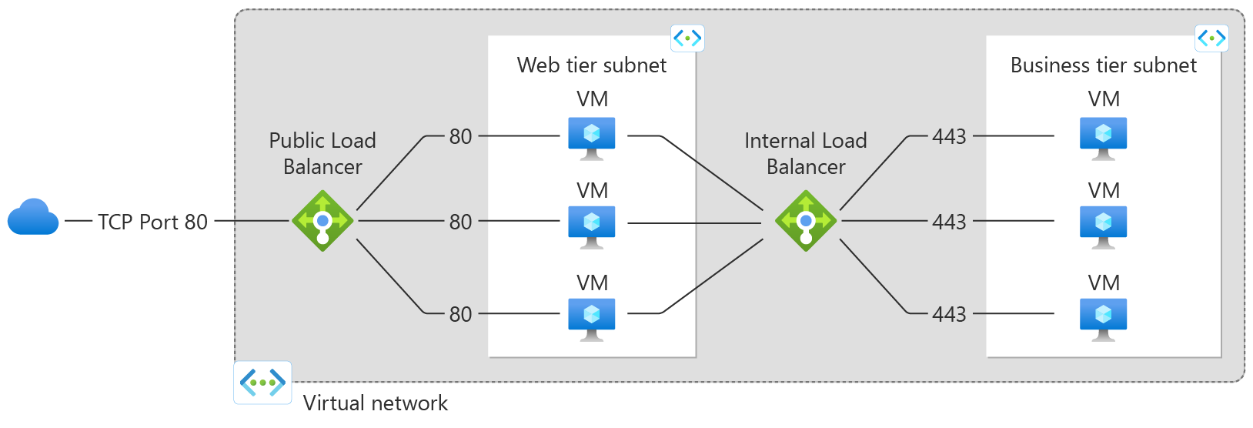

### Azure Load Balancer operates at layer 4 of the Open Systems Interconnection (OSI) model. It's the single point of contact for clients. Load balancer distributes inbound flows that arrive at the load balancer's front end to backend pool instances. These flows are according to configured load-balancing rules and health probes.

### A [**public load balancer**](https://learn.microsoft.com/en-us/azure/load-balancer/components#frontend-ip-configurations) can provide outbound connections for virtual machines (VMs) inside your virtual network. These connections are accomplished by translating their private IP addresses to public IP addresses. Public Load Balancers are used to load balance internet traffic to your VMs.

### An [**internal (or private) load balancer**](https://learn.microsoft.com/en-us/azure/load-balancer/components#frontend-ip-configurations) is used where private IPs are needed at the frontend only. Internal load balancers are used to load balance traffic inside a virtual network. A load balancer frontend can be accessed from an on-premises network in a hybrid scenario.

### 4.Recovery vault

A Recovery Services vault is a storage entity in Azure that houses data. The data is typically copies of data, or configuration information for virtual machines (VMs), workloads, servers, or workstations. You can use Recovery Services vaults to hold backup data for various Azure services such as IaaS VMs (Linux or Windows) and SQL Server in Azure VMs. Recovery Services vaults support System Centre DPM, Windows Server, Azure Backup Server, and

more. Recovery Services vaults make it easy to organize your backup data, while minimizing management overhead.

Recovery Services vaults are based on the Azure Resource Manager model of Azure, which provides features such as:

* + Enhanced capabilities to help secure backup data: With Recovery Services vaults, Azure Backup provides security capabilities to protect cloud backups. The security features ensure you can secure your backups, and safely recover data, even if production and backup servers are compromised.
  + Central monitoring for your hybrid IT environment: With Recovery Services vaults, you can monitor not only your [Azure IaaS VMs](https://learn.microsoft.com/en-us/azure/backup/backup-azure-manage-vms) but also your [on-premises assets](https://learn.microsoft.com/en-us/azure/backup/backup-azure-manage-windows-server#manage-backup-items) from a central portal.

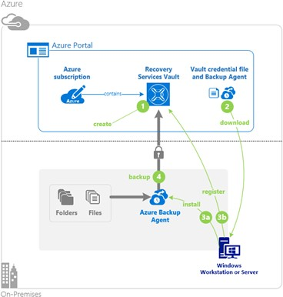

* + Azure role-based access control (Azure RBAC): Azure RBAC provides fine-grained access management control in Azure. [Azure provides various built-in roles](https://learn.microsoft.com/en-us/azure/role-based-access-control/built-in-roles), and Azure Backup has three [built-in roles to manage recovery points](https://learn.microsoft.com/en-us/azure/backup/backup-rbac-rs-vault). Recovery Services vaults are compatible with Azure RBAC, which restricts backup and restore access to the defined set of user roles.
  + Soft Delete: With soft delete, even if a malicious actor deletes a backup (or backup data is accidentally deleted), the backup data is retained for 14 additional days,

allowing the recovery of that backup item with no data loss. The additional 14 days of retention for backup data in the "soft delete" state don't incur any cost to you.

* + Cross Region Restore: Cross Region Restore (CRR) allows you to restore Azure VMs in a secondary region, which is an Azure paired region. By enabling this feature at

the [vault level,](https://learn.microsoft.com/en-us/azure/backup/backup-create-rs-vault#set-cross-region-restore) you can restore the replicated data in the secondary region any time, when you choose. This enables you to restore the secondary region data for audit- compliance, and during outage scenarios, without waiting for Azure to declare a disaster (unlike the GRS settings of the vault).

# IMPLEMENTATION

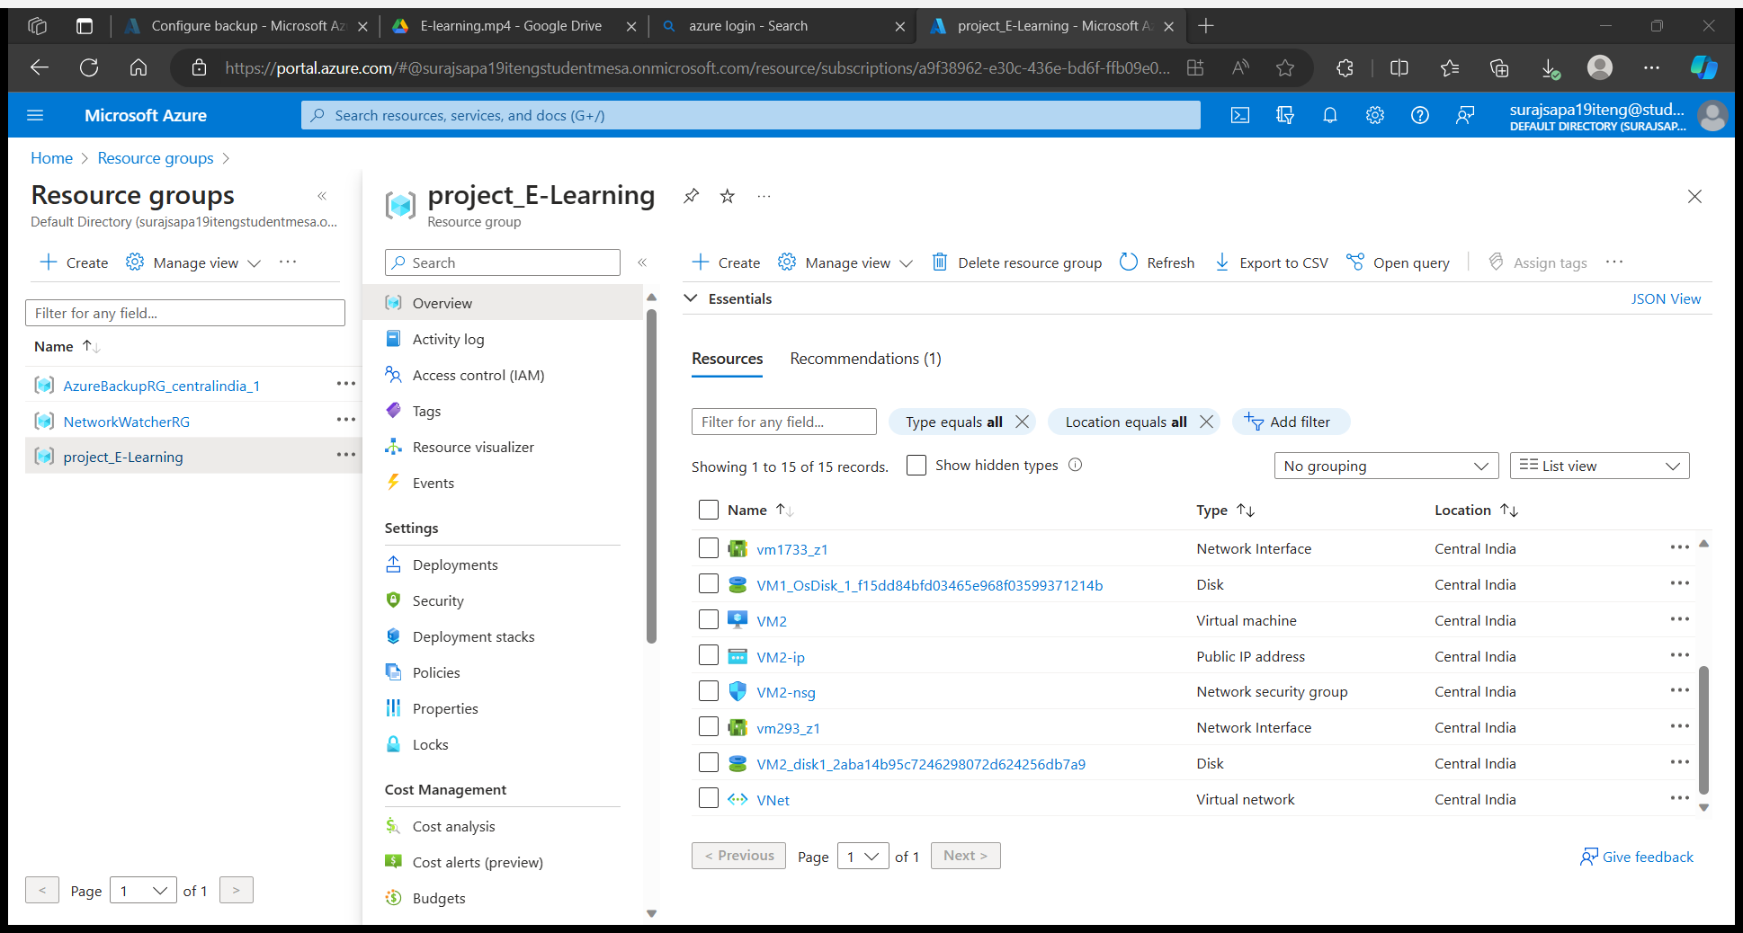

1.We first created 2 VMs and hosted the same WordPress website on it.

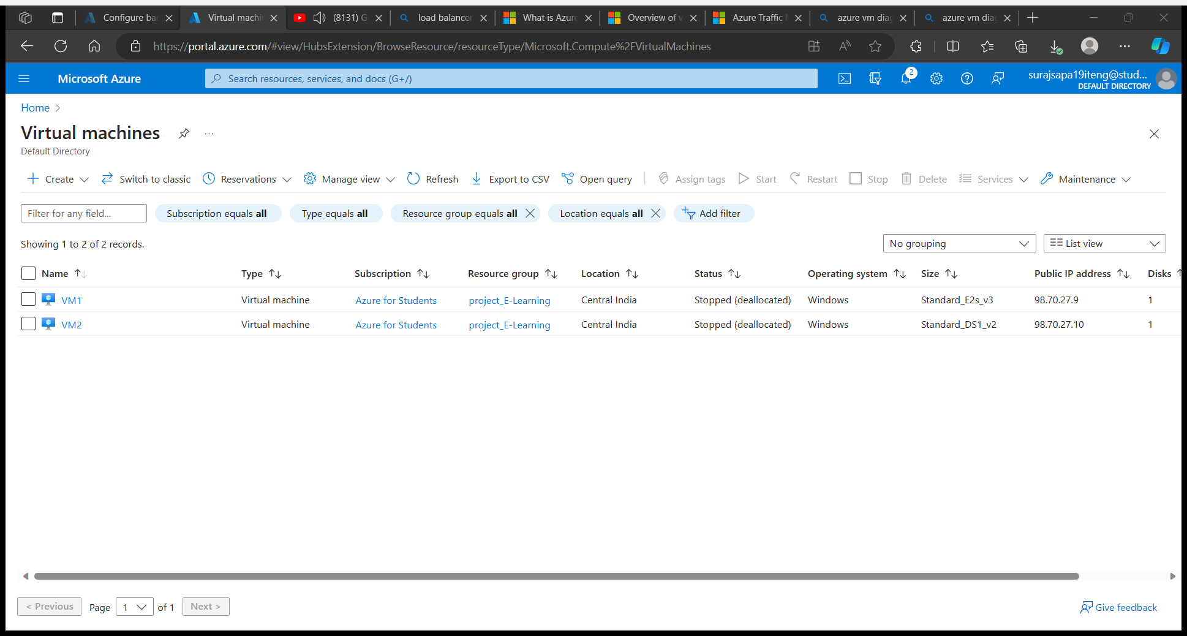

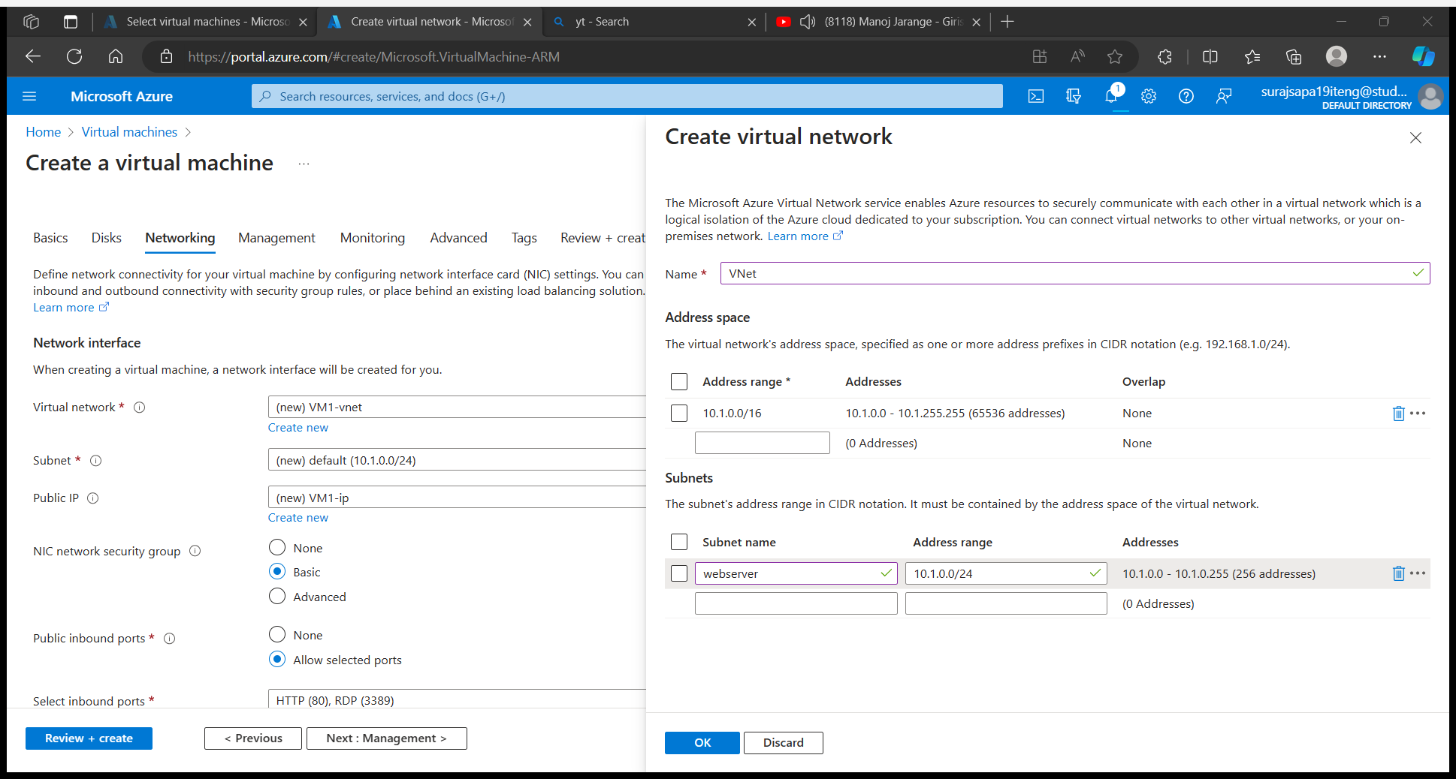

2. Now add feature web server(IIS)deploy the Web site in VM1 and VM2

**IIS Service:**

IIS stands for **Internet Information Services**is a flexible, general-purpose [web server](https://www.techtarget.com/whatis/definition/Web-server) from Microsoft that runs on Windows systems to serve requested [HTML](https://www.theserverside.com/definition/HTML-Hypertext-Markup-Language) pages or files.

An IIS web server accepts requests from remote client computers and returns the appropriate response. This basic functionality allows web servers to share and deliver information across local area networks ([LAN](https://www.techtarget.com/searchnetworking/definition/local-area-network-LAN)), such as corporate intranets, and wide area networks ([WAN](https://www.techtarget.com/searchnetworking/definition/WAN-wide-area-network)), such as the Internet.

A web server can deliver information to users in several forms, such as static webpages coded in HTML; through file exchanges as downloads and uploads; and text documents, image files and more.

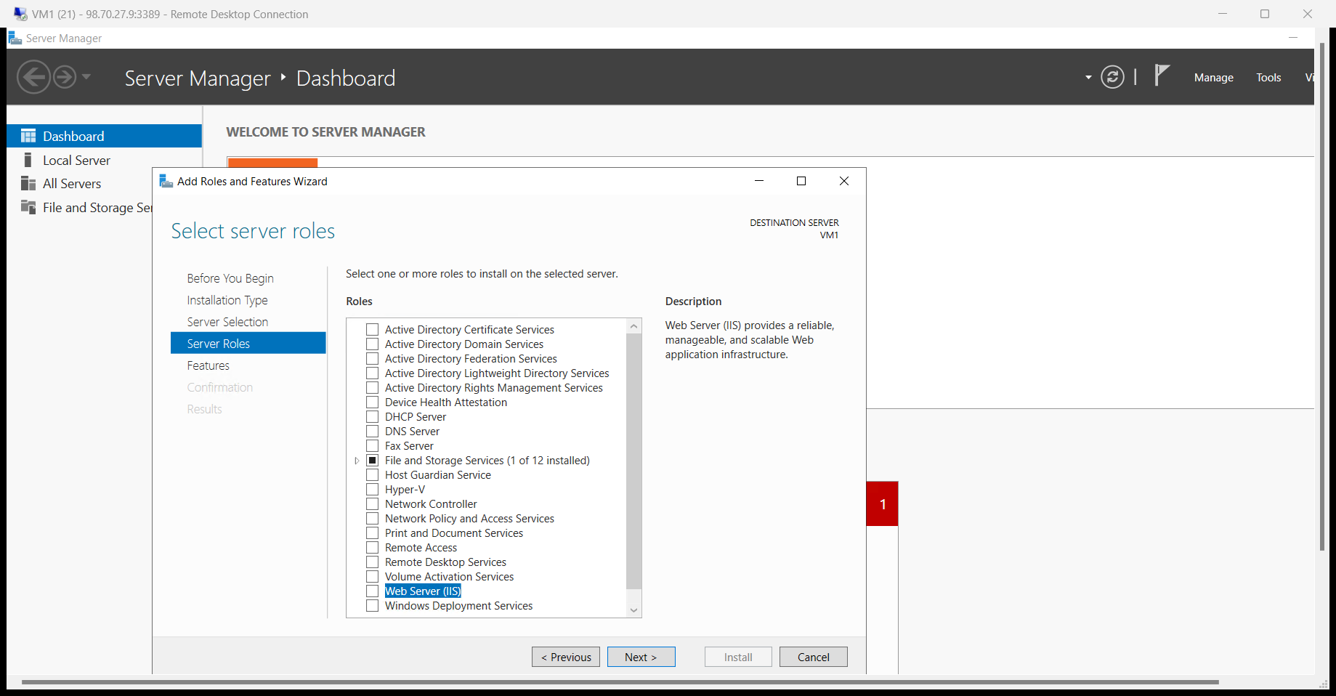

Now copy a IP of VM1 and paste on portal to check web site is working or not

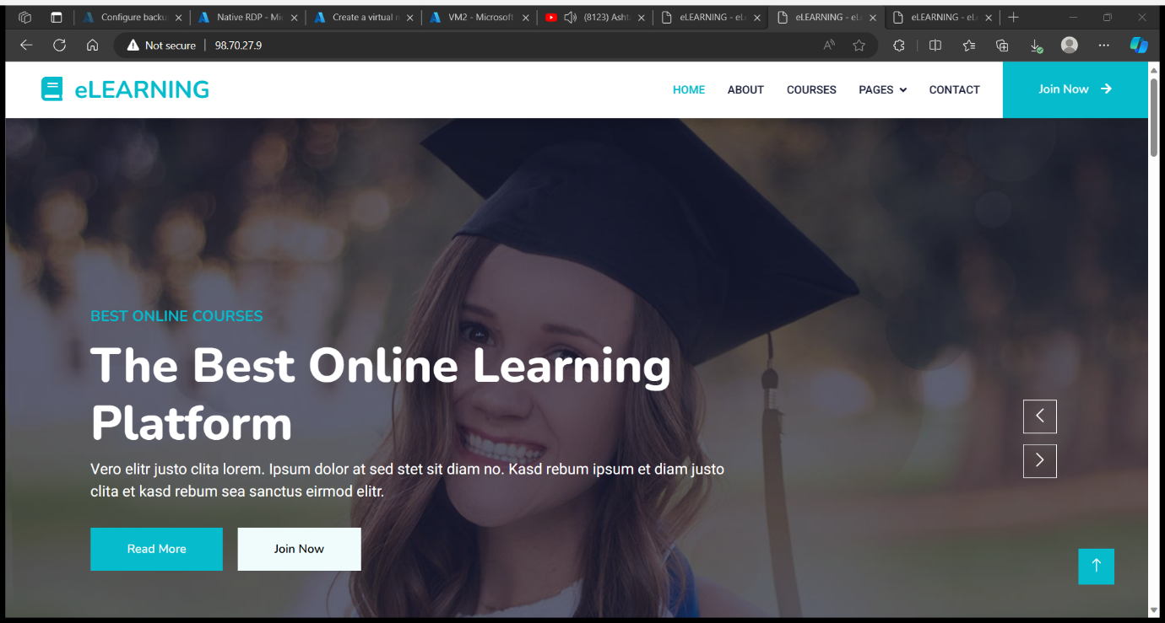

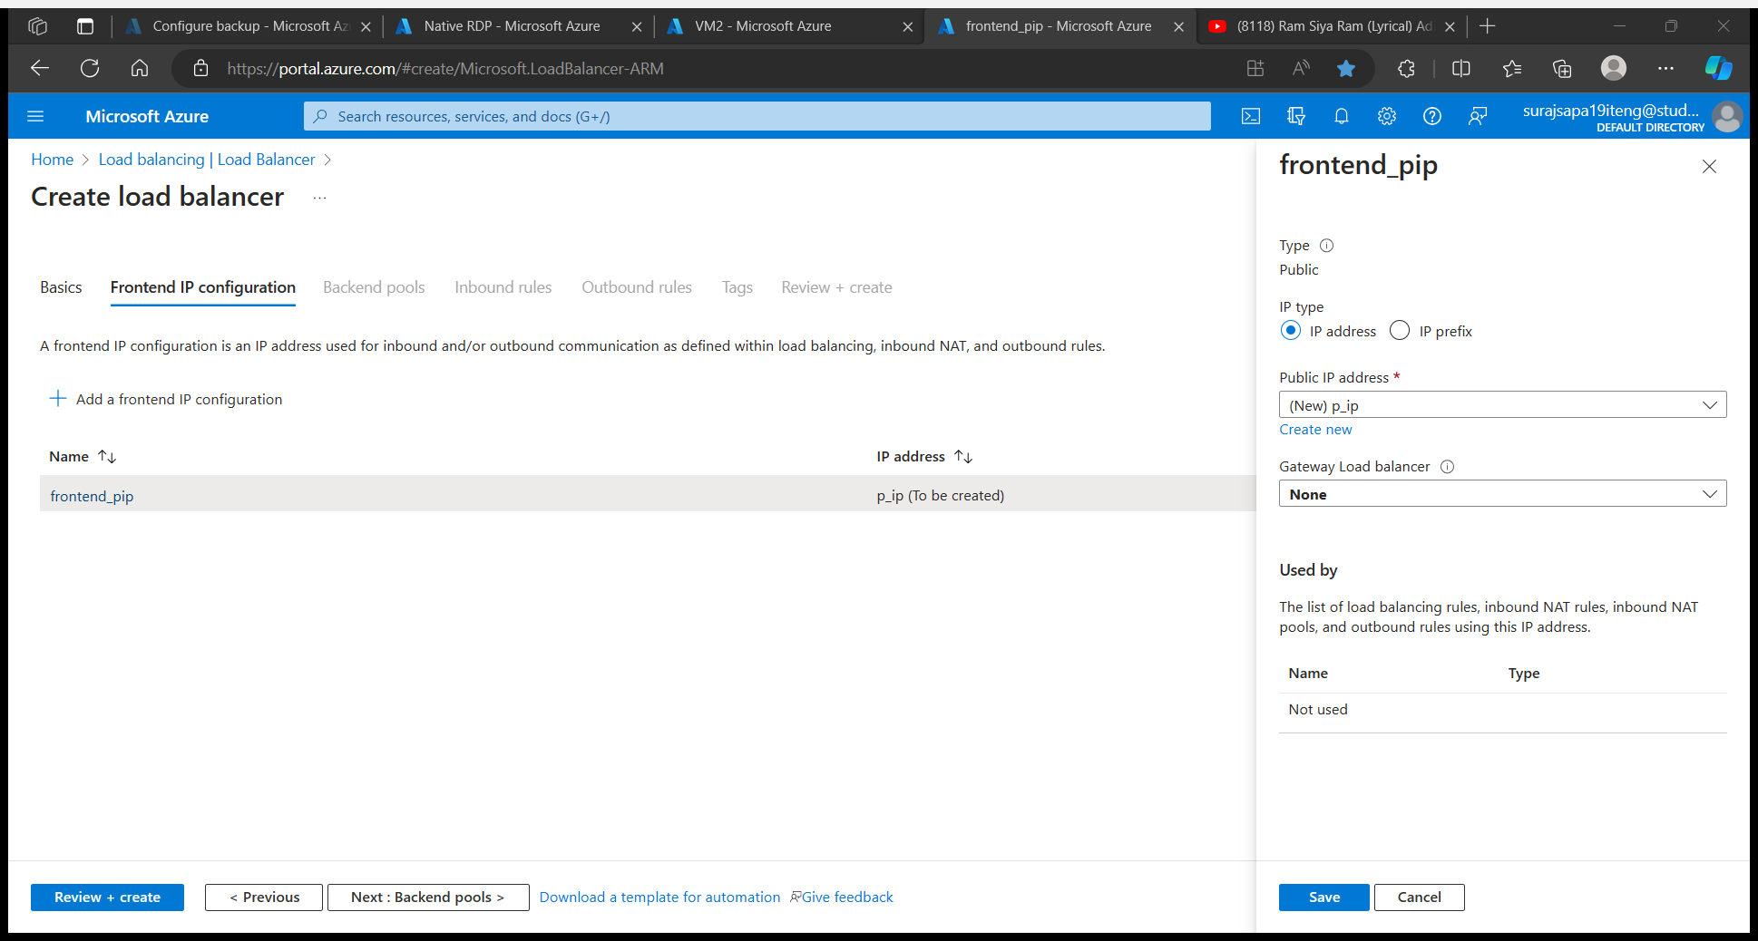

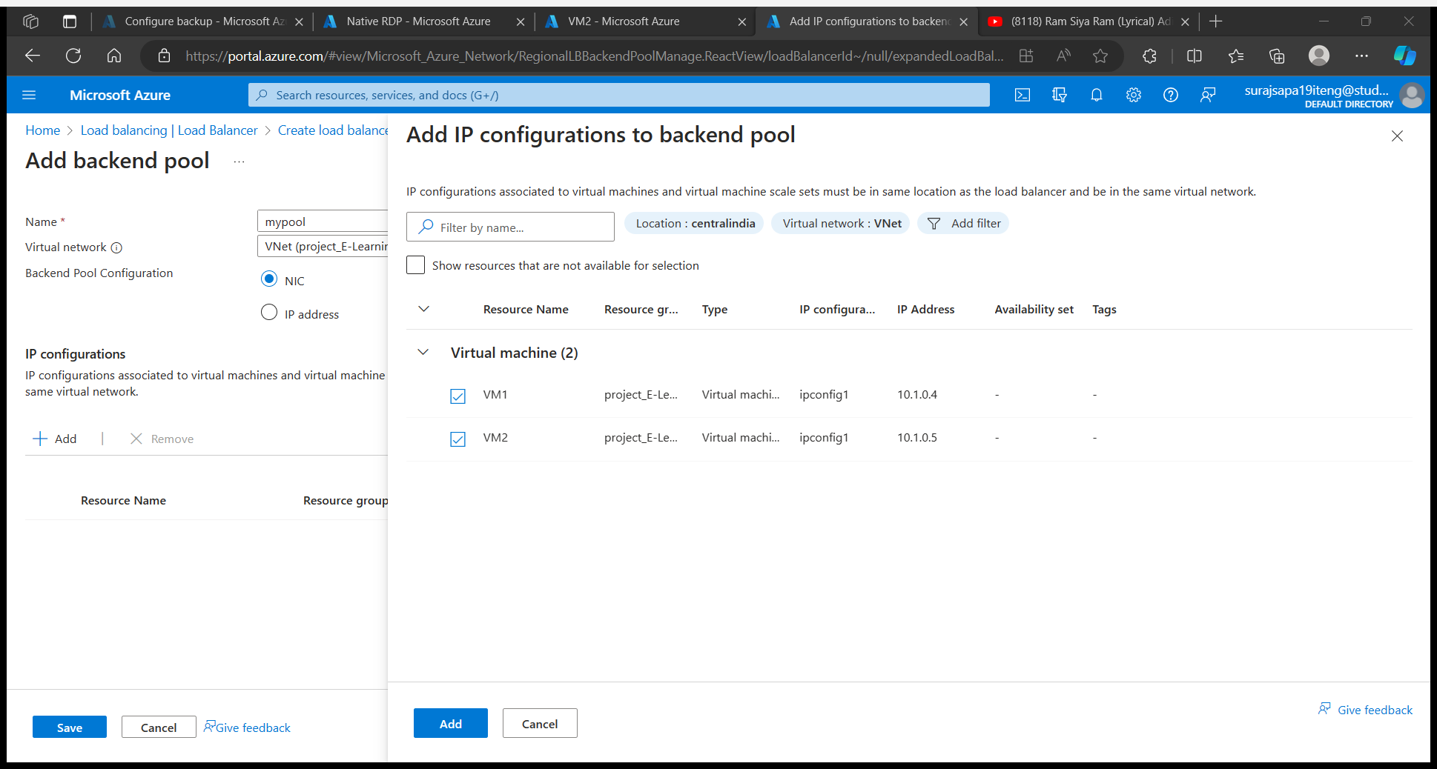

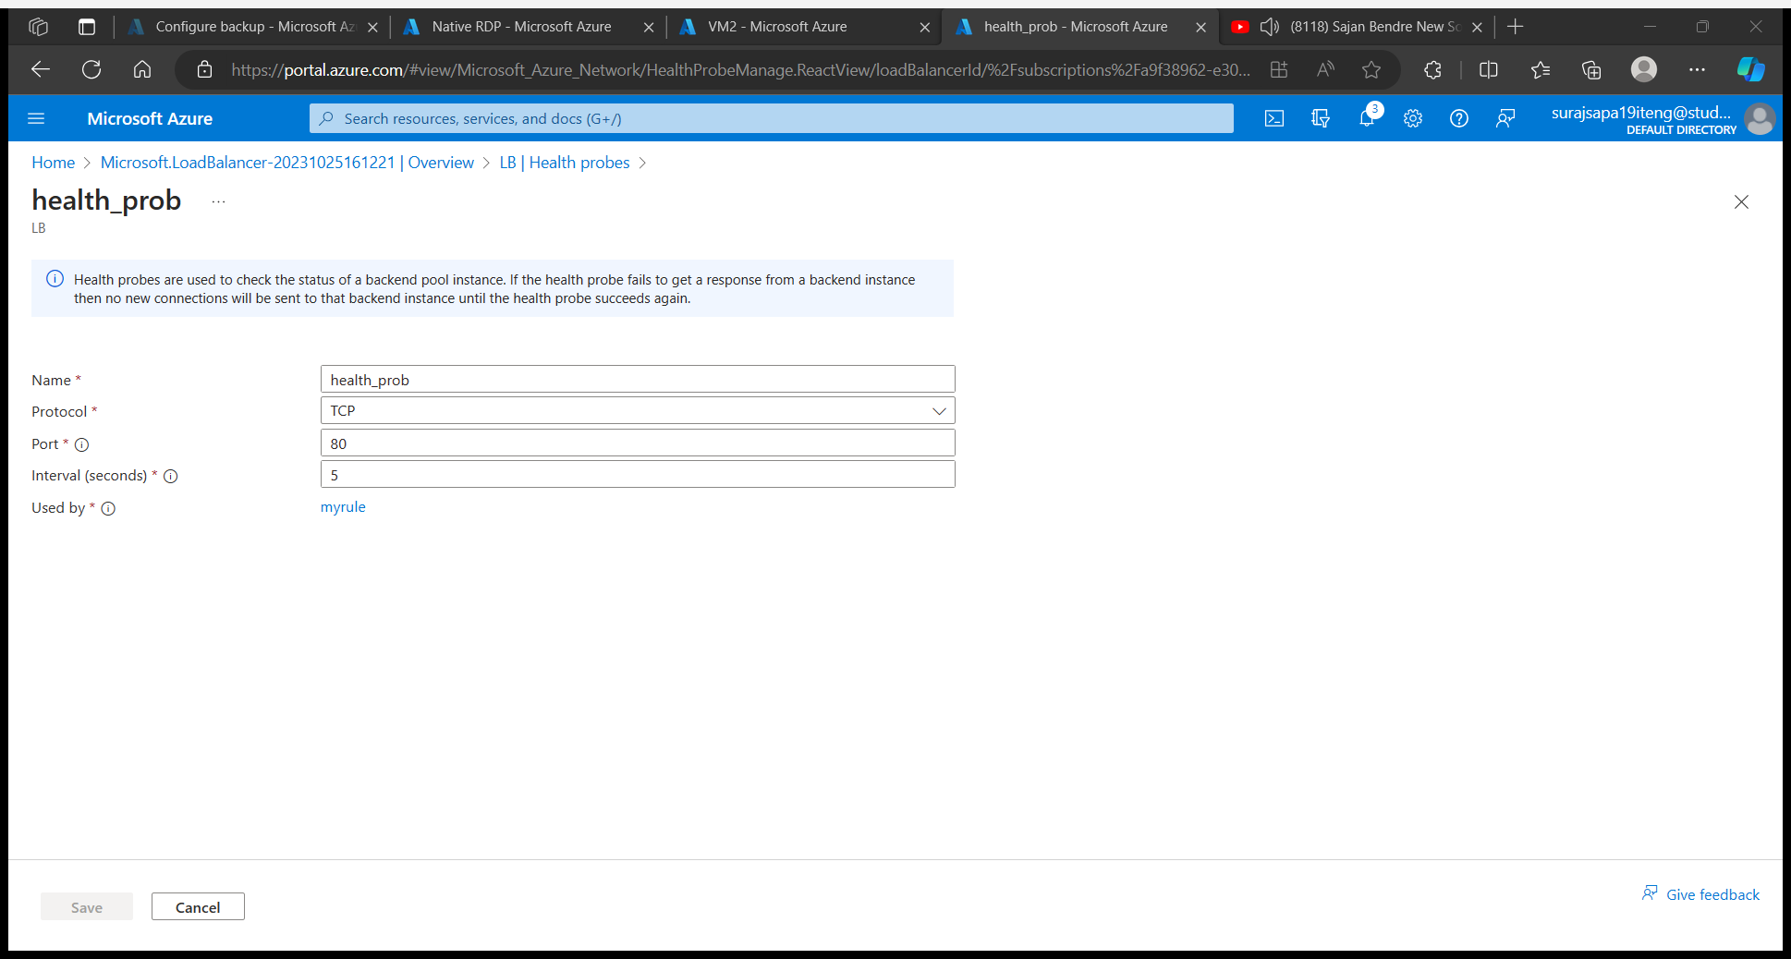

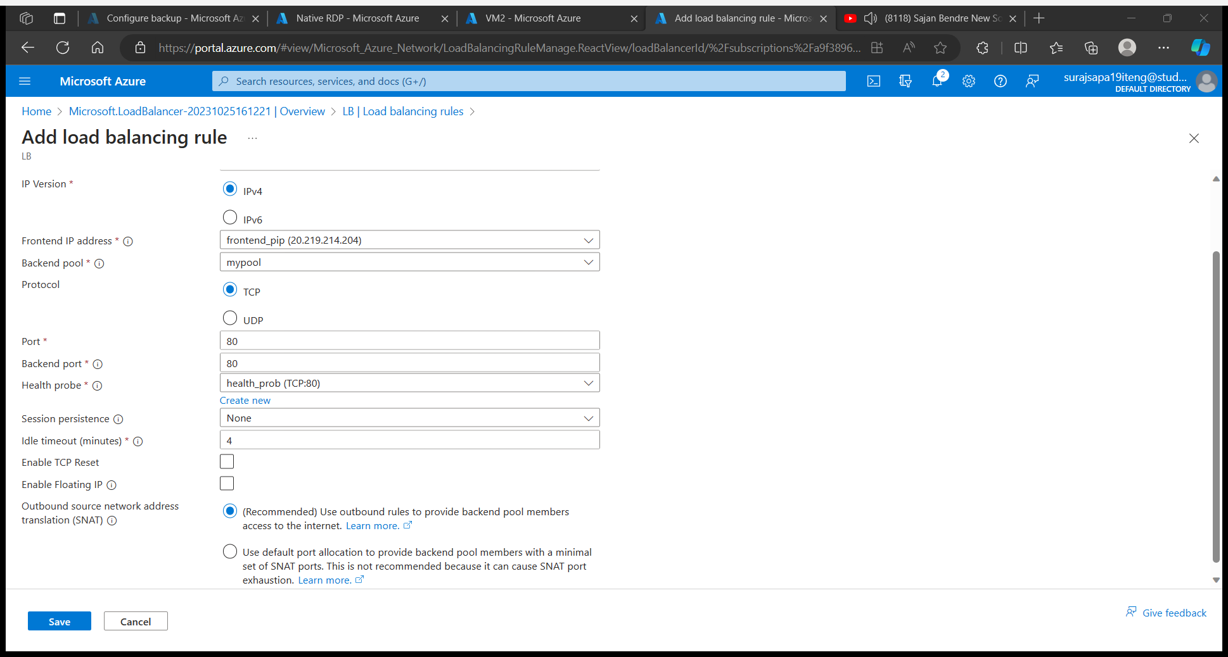



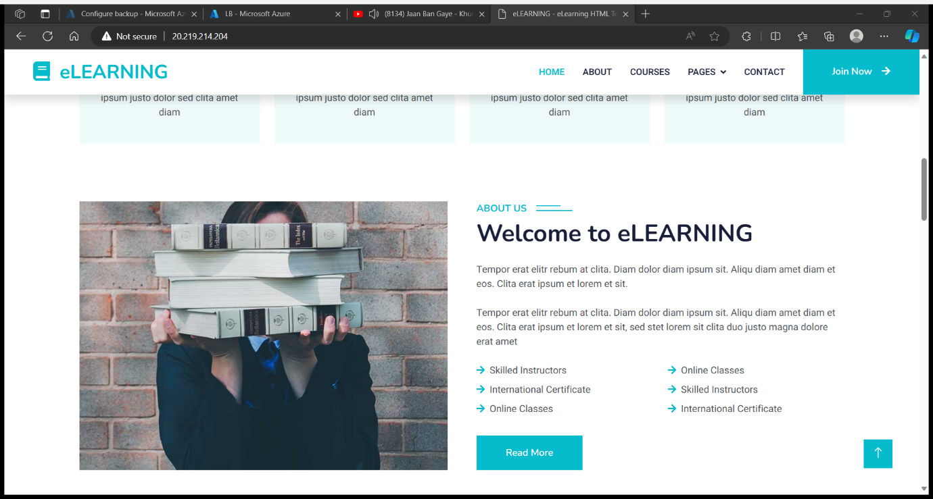

Create a recovery vault for Virtual machine backup purpose

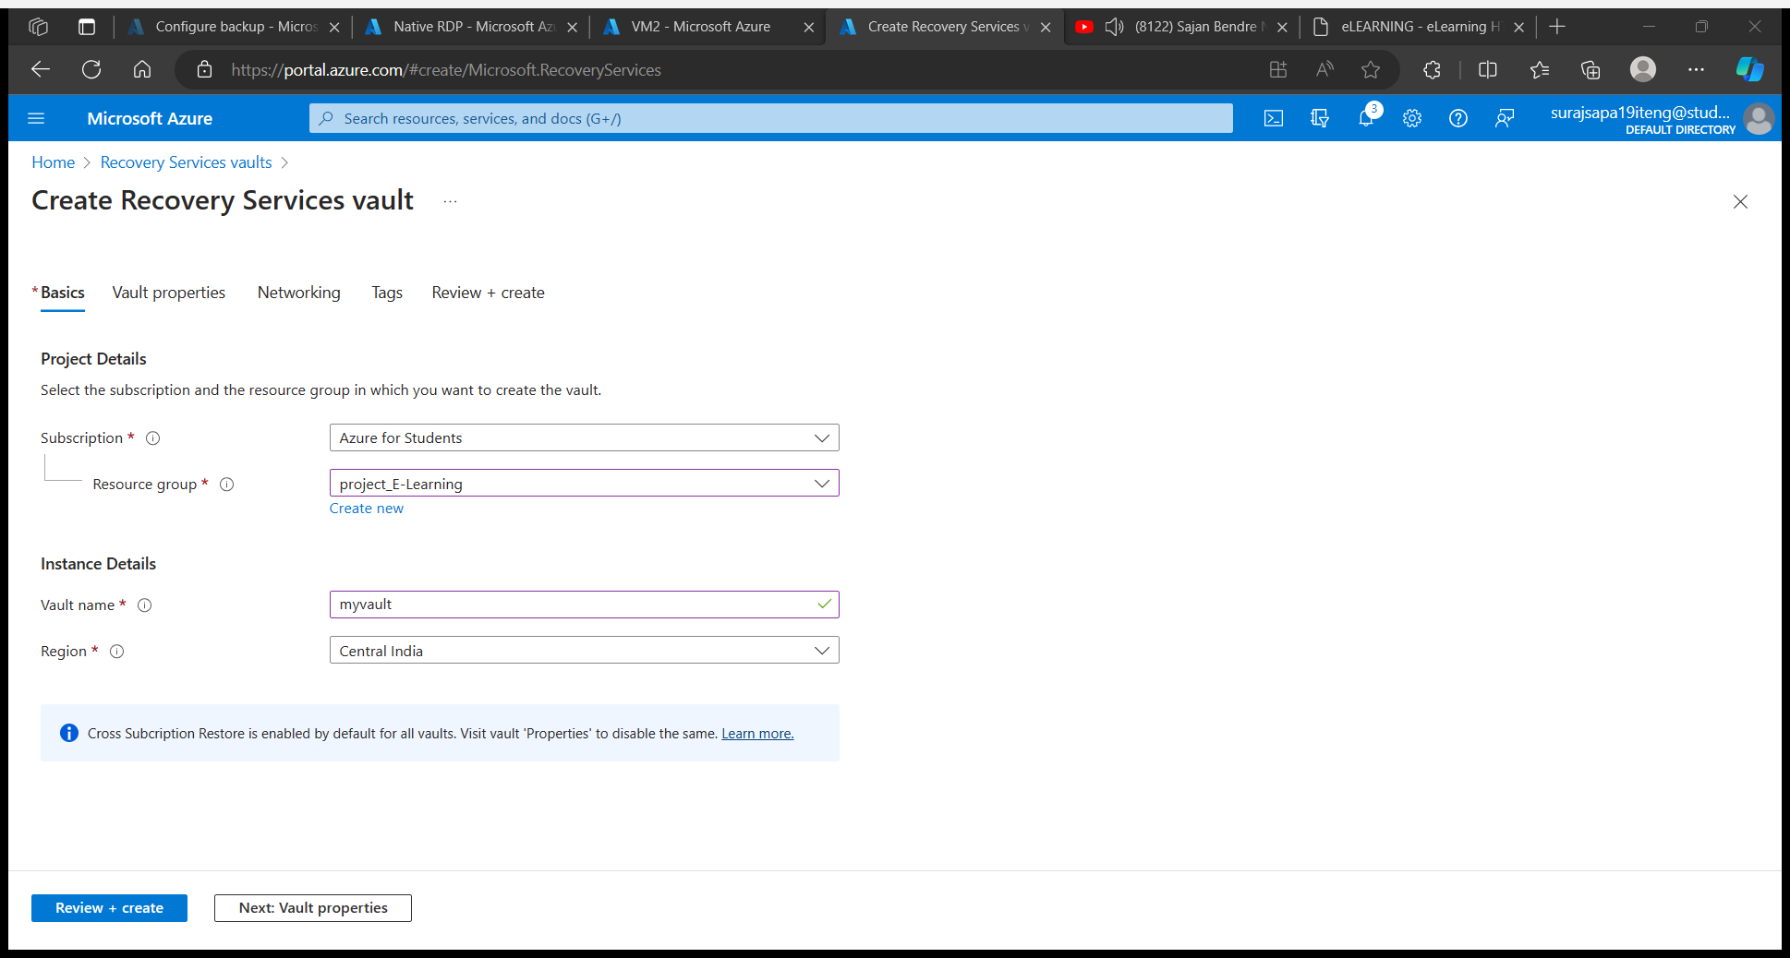

Select virtual machine backup option and after that click on add button and add two Virtual machine

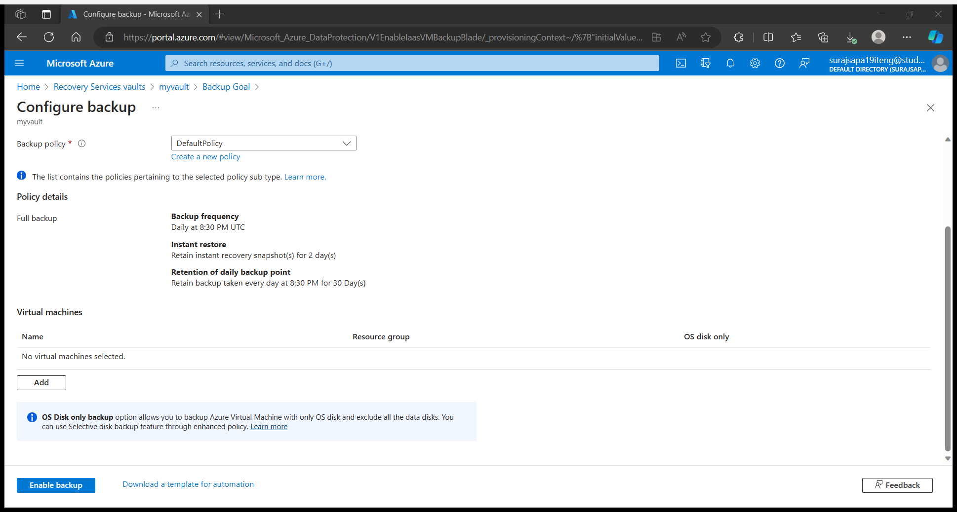

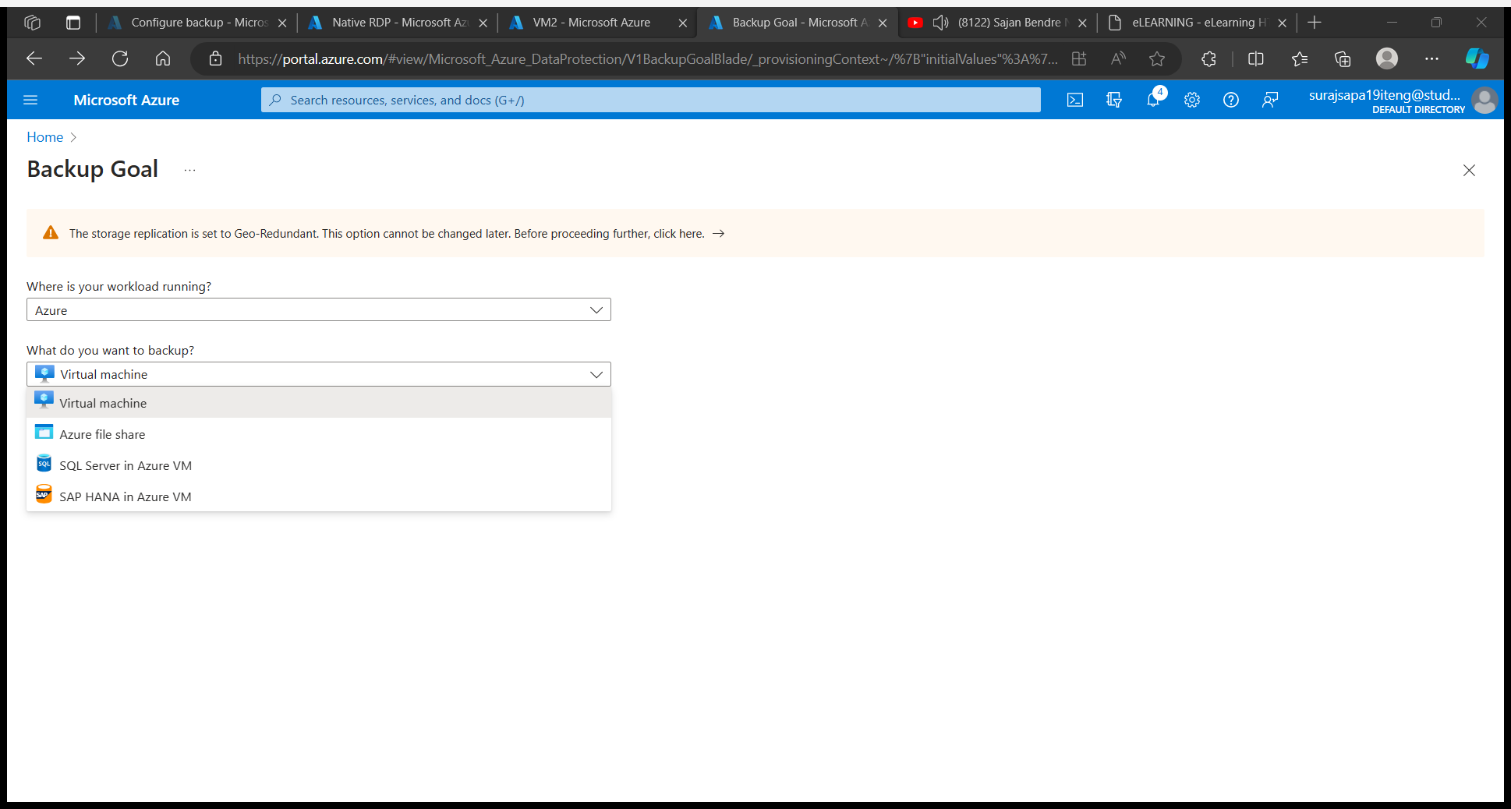

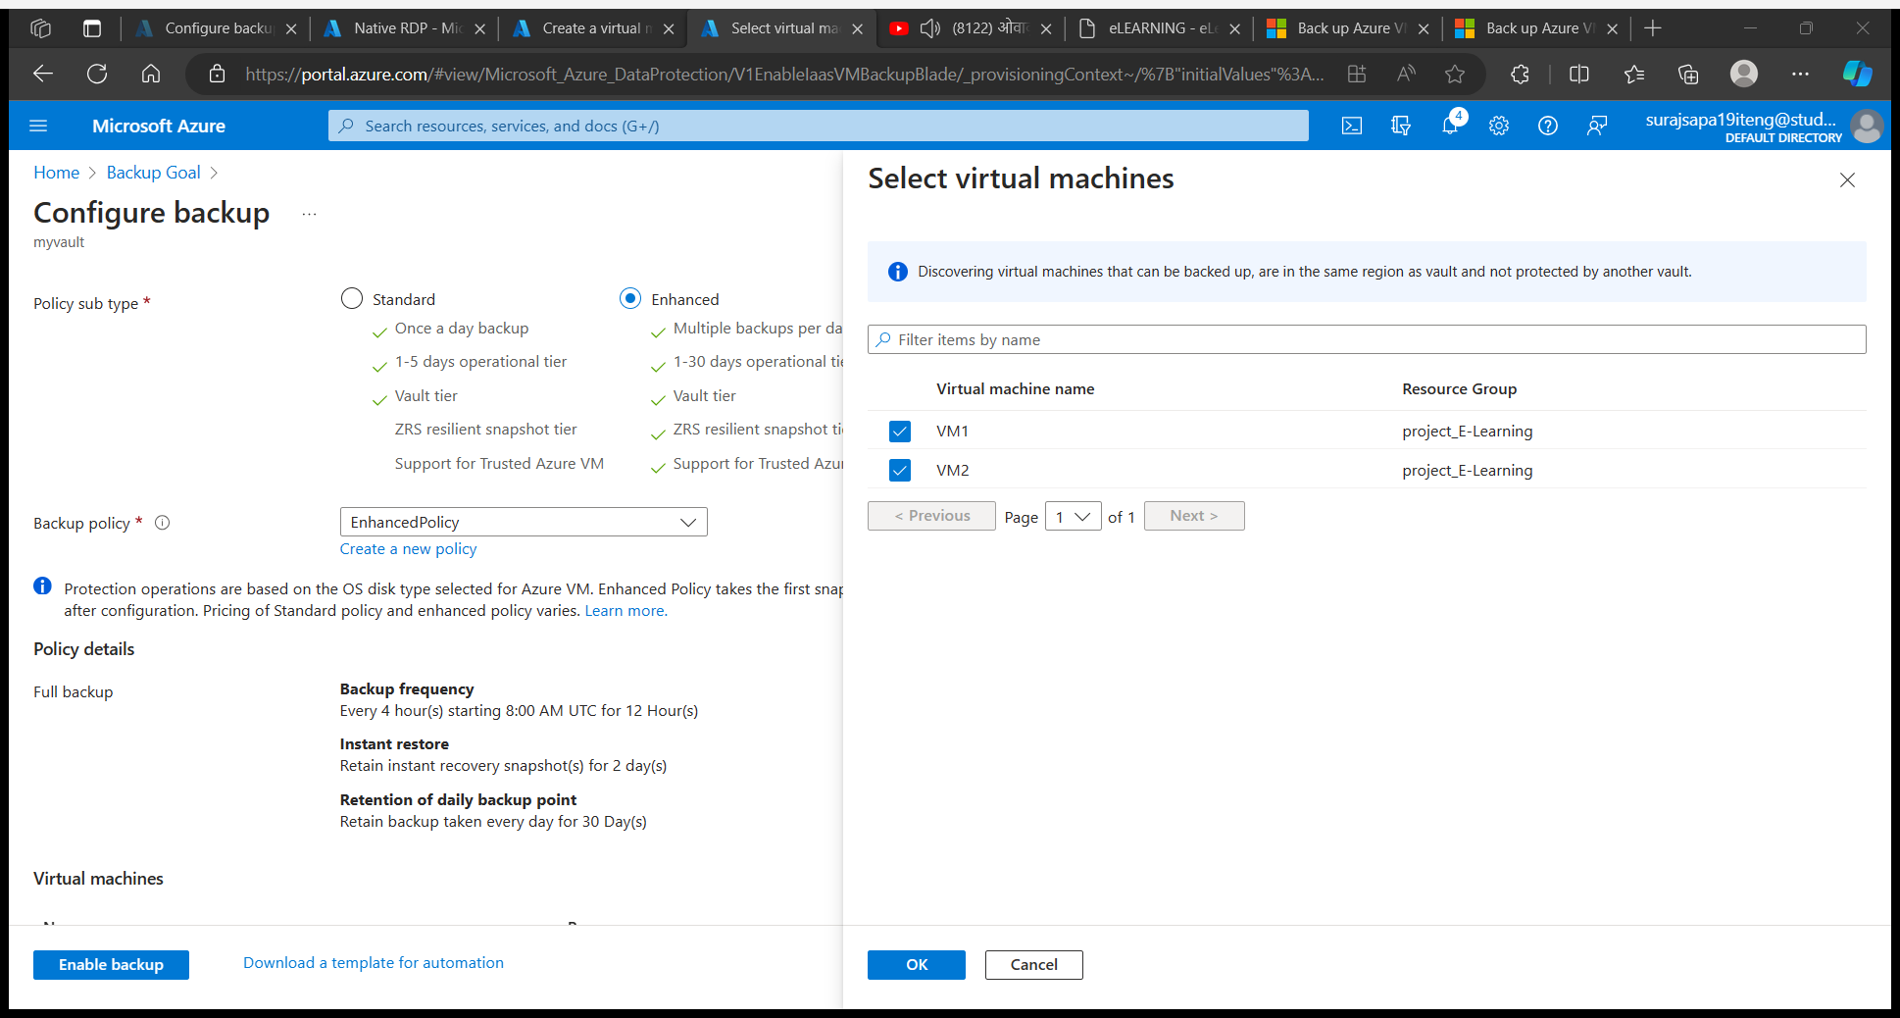

Then we backed up both the VMs using Azure Recovery Service Vault.

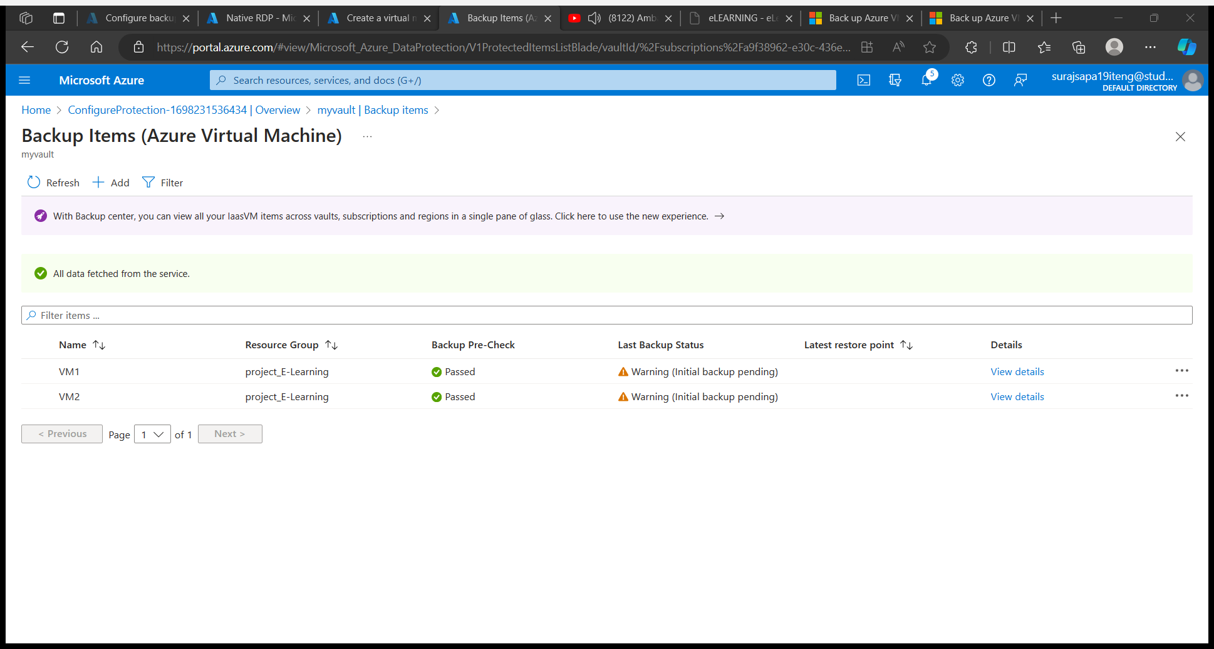

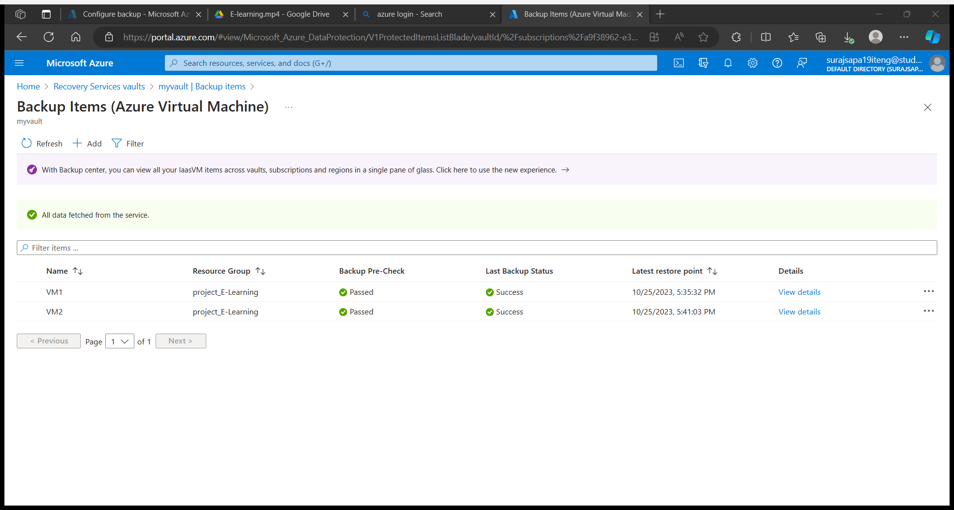

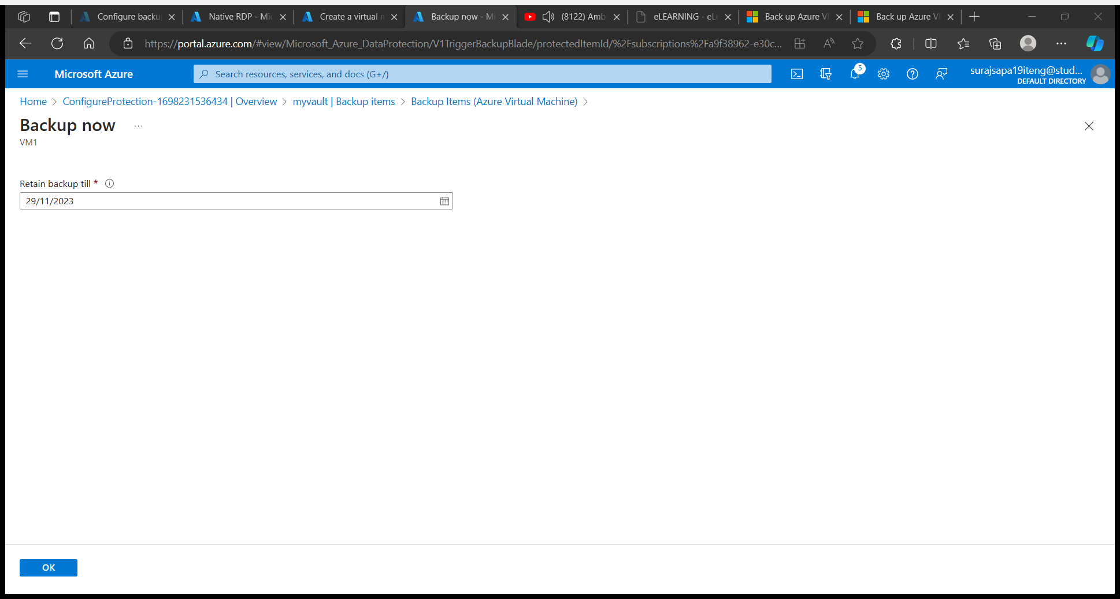

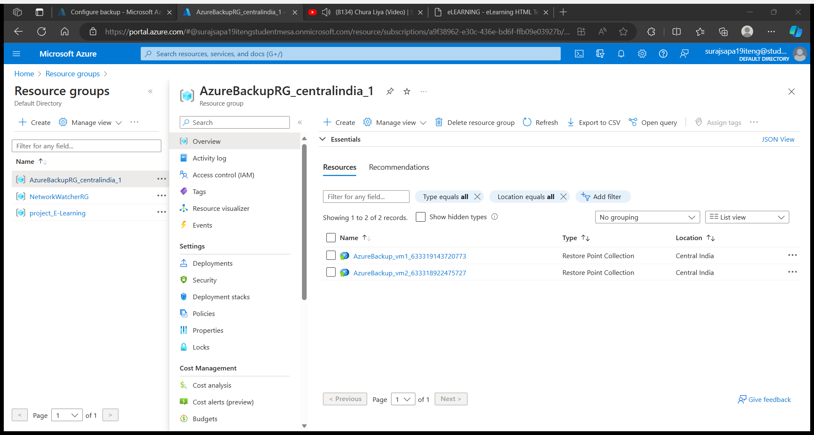

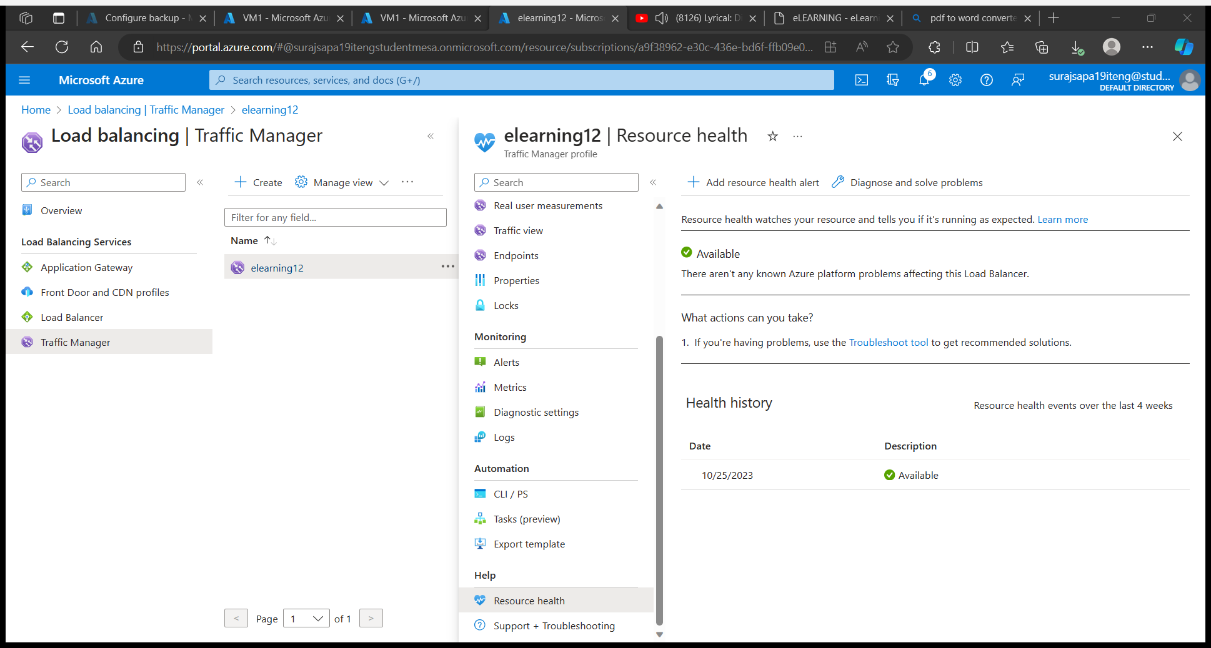

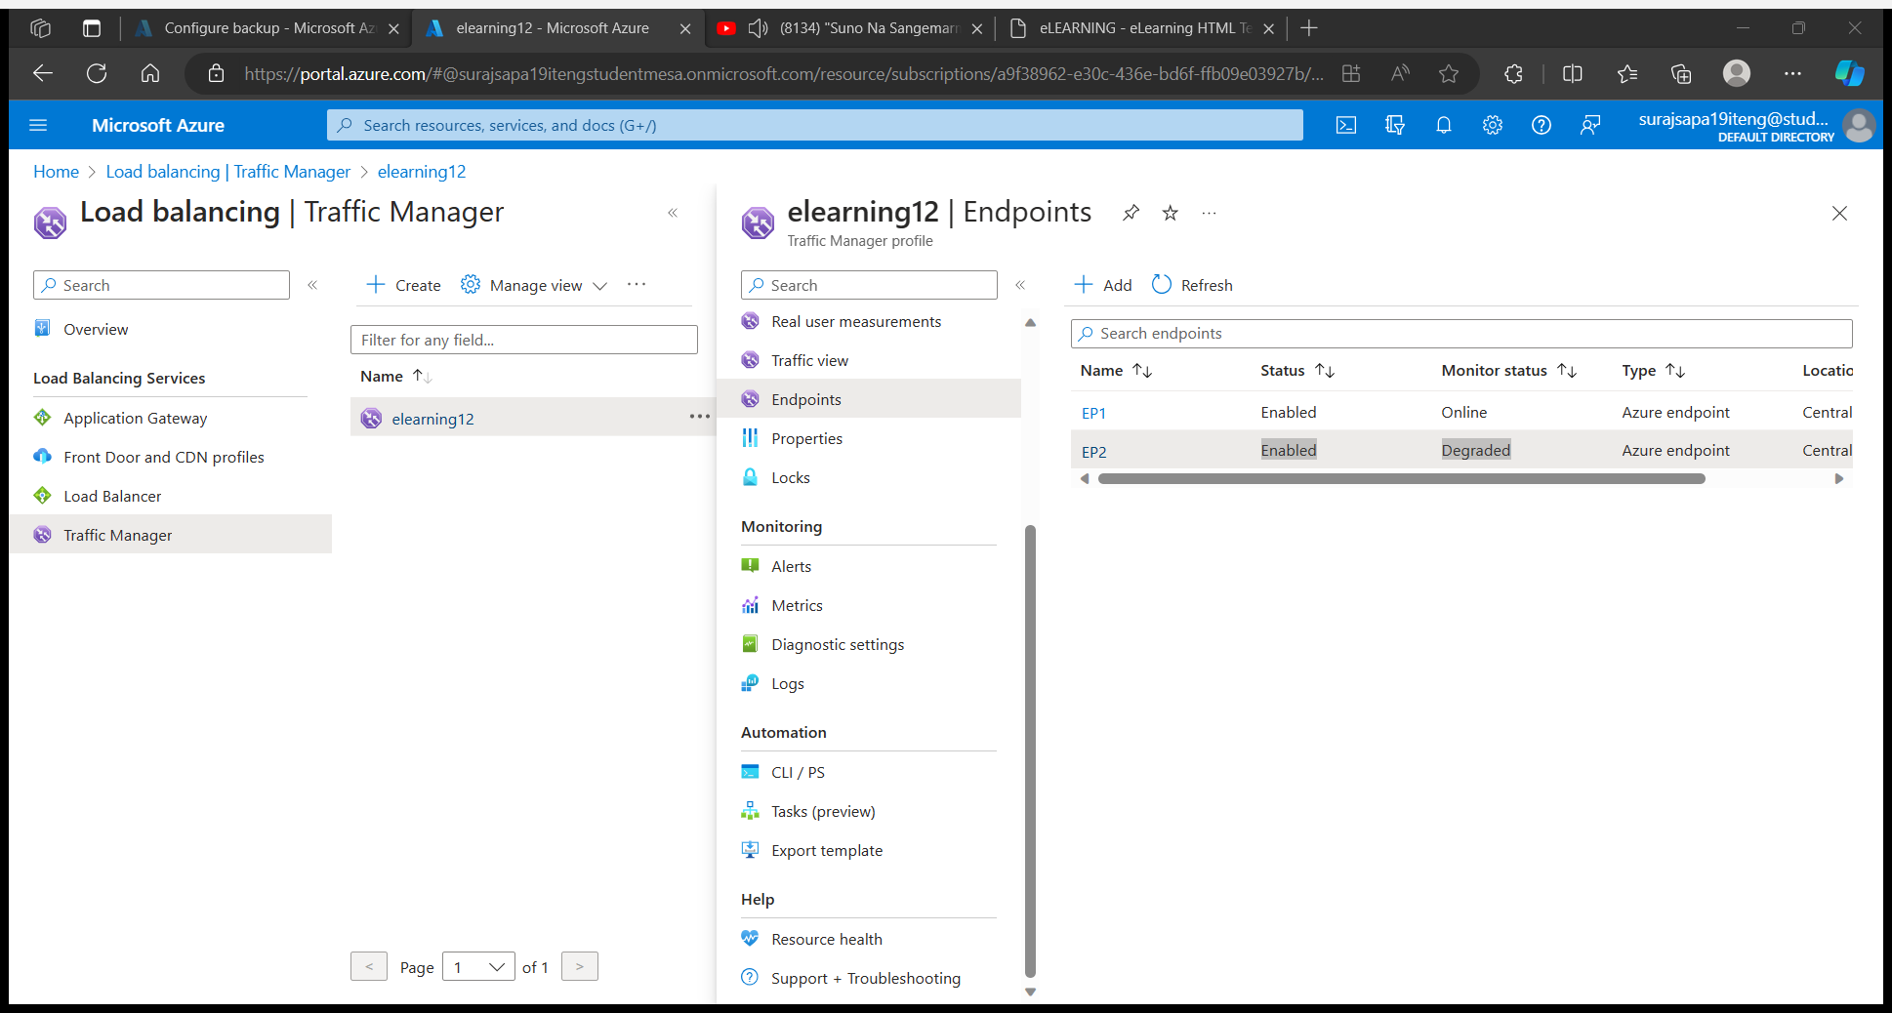

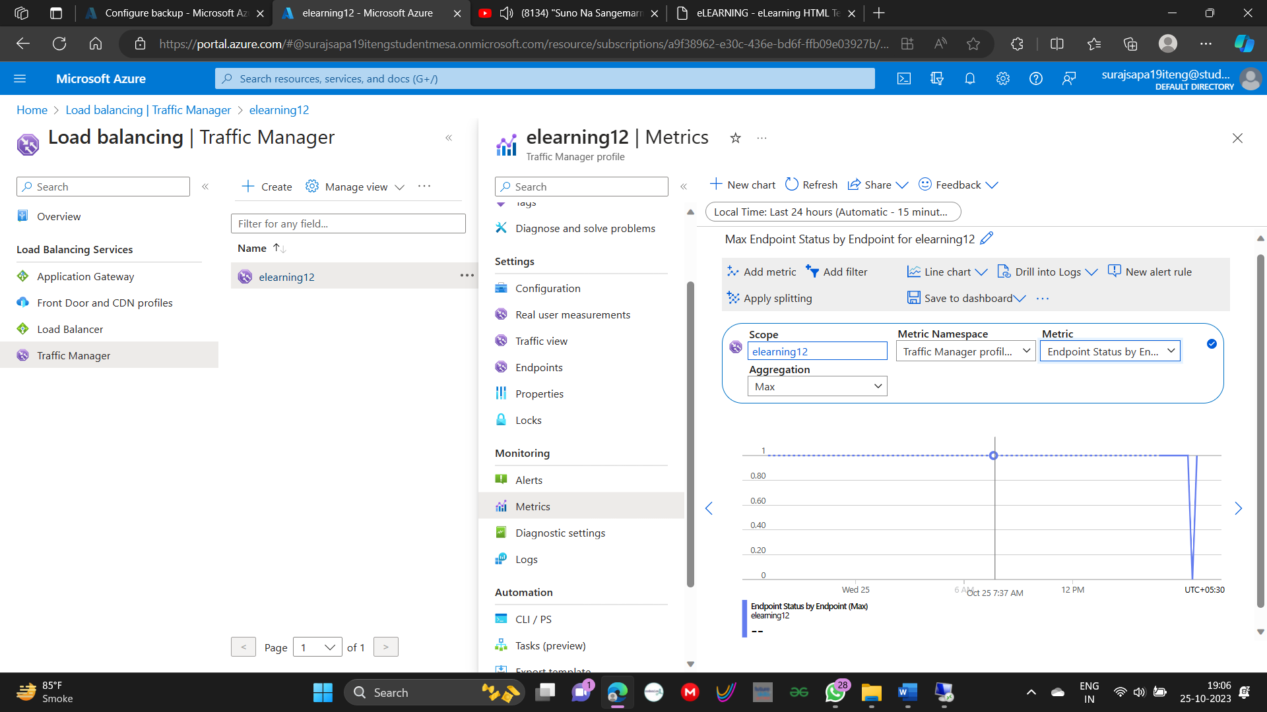

# Website Overview

